SolutionBuilder – Mini HOWTO

Create project paths
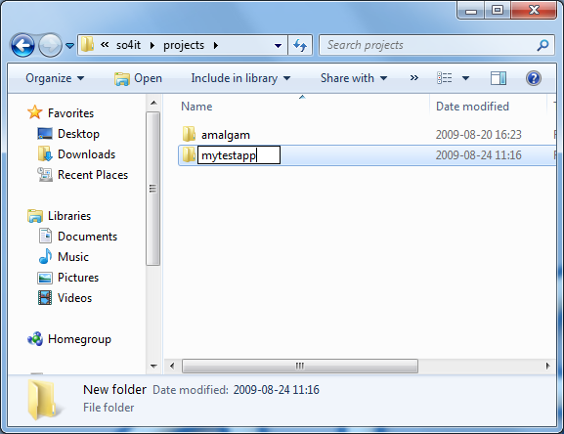
Create following paths where you would like to have your project:
mytestapp/
mytestapp/code/
mytestapp/code/TestApp

Create solution file
Start SolutionBuilderUI (<Your traktor path>/bin/SolutionBuilderUI.exe)
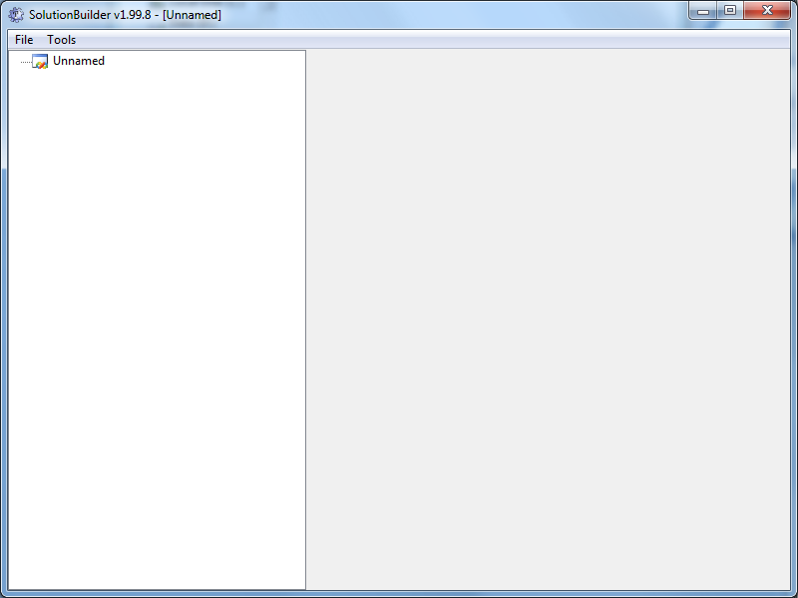
- Rename ”Unnamed” solution to ”MyTestApp” by double-click on tree node.
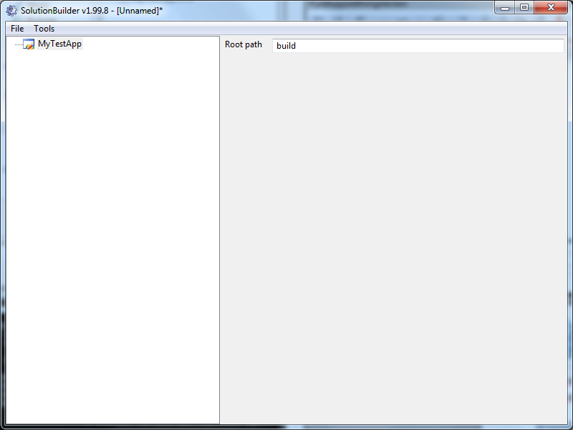
- Select MyTestApp node and enter Root path as ”build”
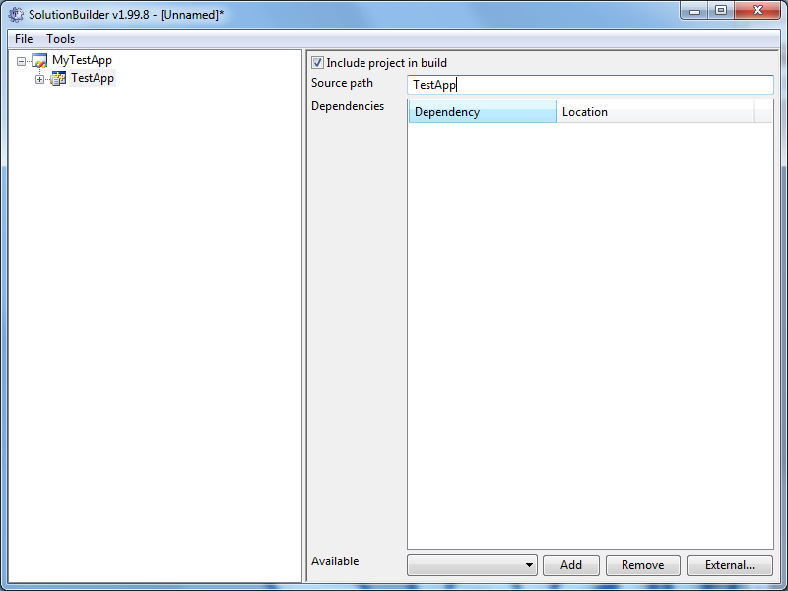
- Right click on MyTestApp node and select Add New Project, rename project to ”TestApp”. Also enter ”TestApp” as the source path.
- Right click on TestApp node and select Add New File, a default ”*.*” wildcard file is added but this can be changed when necessary.
- Again right click on TestApp but this time select Add New Configuration.
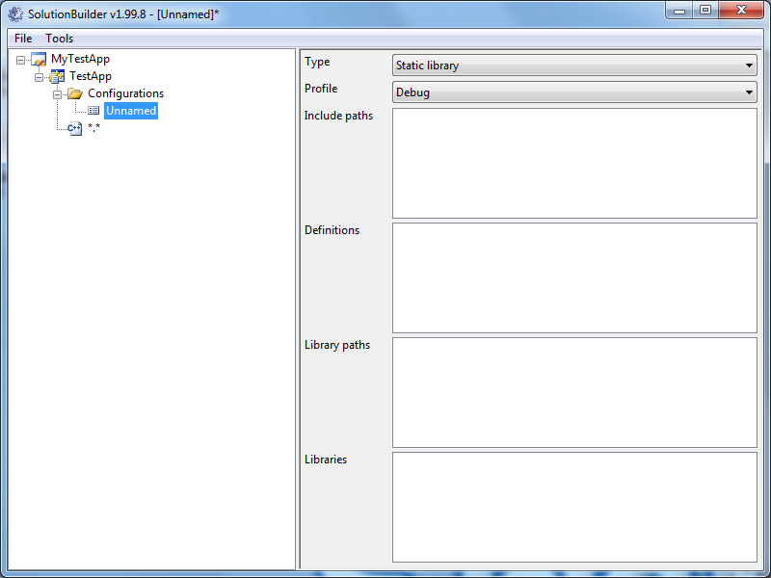
- Rename configuration from ”Unnamed” to ”Release”, change type to Executable (Console) and profile to Release.
- Save solution as ”MyTestApp.xms” in the project path.
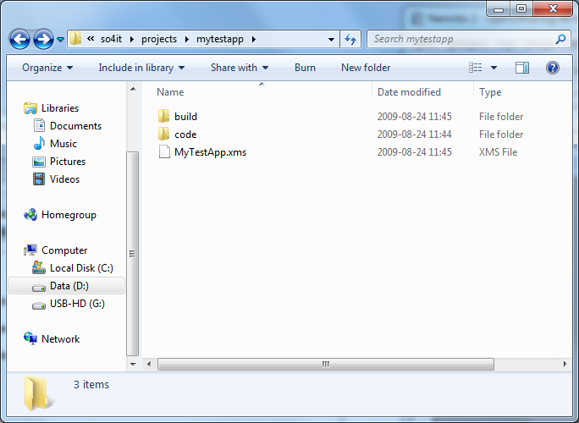
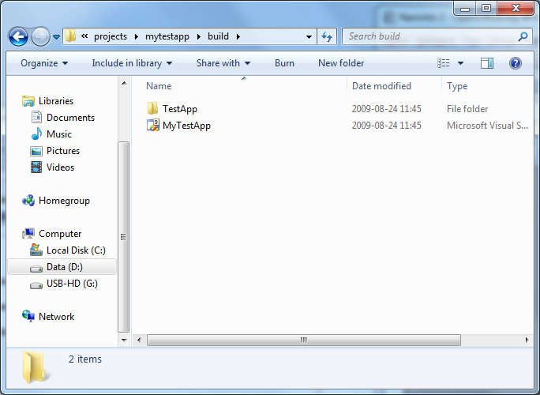
- In order to generate Visual Studio 2008 solution run following command
SolutionBuilder -f=msvc -p=<Your traktor path>\bin\msvc-2008-win32.xml MyTestApp.xms
- Open your Visual Studio solution as always.

